LIFE WHEEL

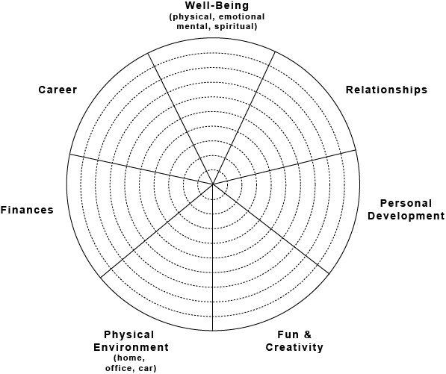

Option 1: What are your current circumstances, concerns, goals and vision for each area? Discuss in detail.

Option 2: Rate your level of satisfaction for each area on a scale from 1 – 10, where 10 is greatest satisfaction. Write the number in the “pie slice” for that area, or fill in the slice from the center outward, based on your rating, e.g., for a rating of 5, fill the slice in from the center halfway to the outer edge.

